**Wire-Frame Design**

**RESTAURANT RATING PREDICTION**

|  |  |
| --- | --- |
| Written By | Ganesh Sayaji Thorat |
| Document Version | 1.0 |
| Last Revised Date | 25-01-2022 |

**Document Change Control Record:**

|  |  |  |  |
| --- | --- | --- | --- |
| **Version** | **Date** | **Author** | **Comments** |
|  |  |  |  |
|  |  |  |  |
|  |  |  |  |
|  |  |  |  |
|  |  |  |  |
|  |  |  |  |
|  |  |  |  |
|  |  |  |  |
|  |  |  |  |
|  |  |  |  |
|  |  |  |  |
|  |  |  |  |
|  |  |  |  |
|  |  |  |  |
|  |  |  |  |
|  |  |  |  |

**Reviews**

|  |  |  |  |
| --- | --- | --- | --- |
| **Version** | **Date** | **Reviewer** | **Comments** |
|  |  |  |  |

### **Approval Status:**

|  |  |  |  |  |
| --- | --- | --- | --- | --- |
| **Version** | **Review date** | **Reviewed By** | **Approved By** | **Comments** |
|  |  |  |  |  |

**Webapp Home page:**

On the homepage the user will be able to see the heading of the project name. Also, some buttons to redirect to prediction page. Wireframe of home page is given below

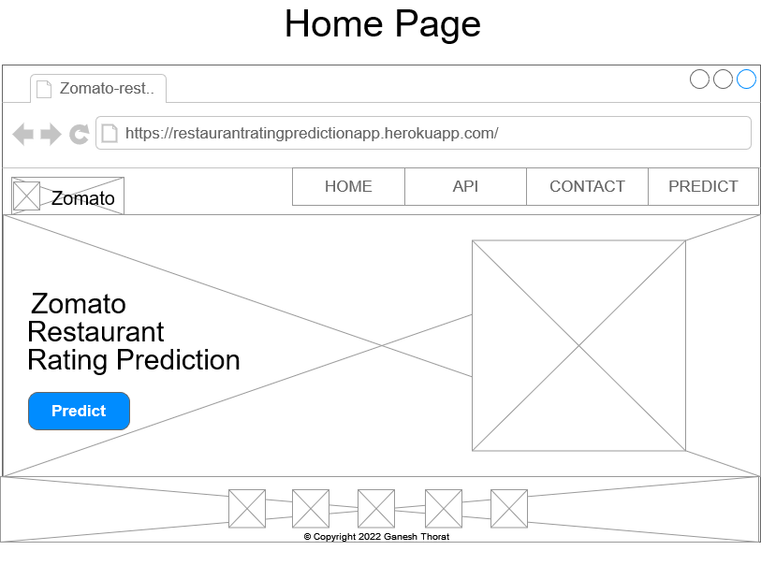

**Prediction Page:**

On this page there will be form for rating prediction. User have to fill all the details and have to click on predict button. Below is the image which shows how form will look like:

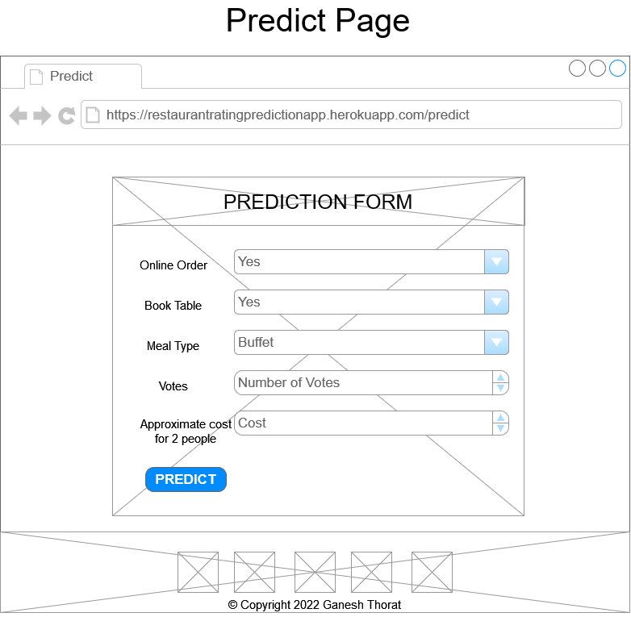

**Result Page:**

After user will give inputs there will be predict button, on clicking predict button the next page will open which will be the result page where the prediction will be shown. Below is the image how the result page will look like:

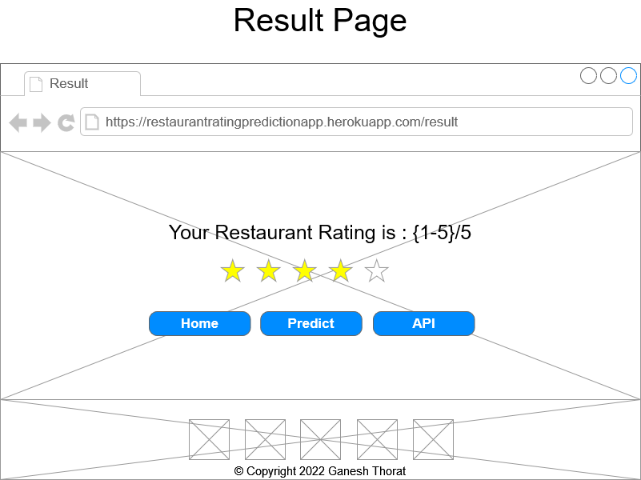

**API home Page:**

After clicking on API button on home page or result page the user will get redirected to API home page which will shows the information of API.

